**Step 1. Copy the bellow signature template**

Best Regards,   
  
**{First Name} {Last Name}**  
Junior Digital Technologist  
  
**Digital Transformation Center Sofia**  
**DXC Technology**  
  
[dxc.technology](http://www.dxc.technology/)   
  
cid:image002.png@01D383DA.73586B40

**** Please consider the environment before printing this e-mail.

**Step 2. Open up Outlook 2016 Desktop Edition**

**1.** Select **File > Options**

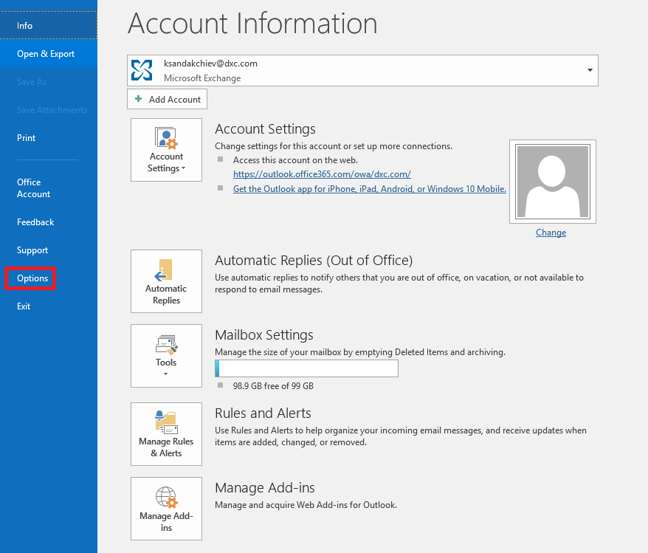

2. Select the **Mail** tab and then **Signatures**.

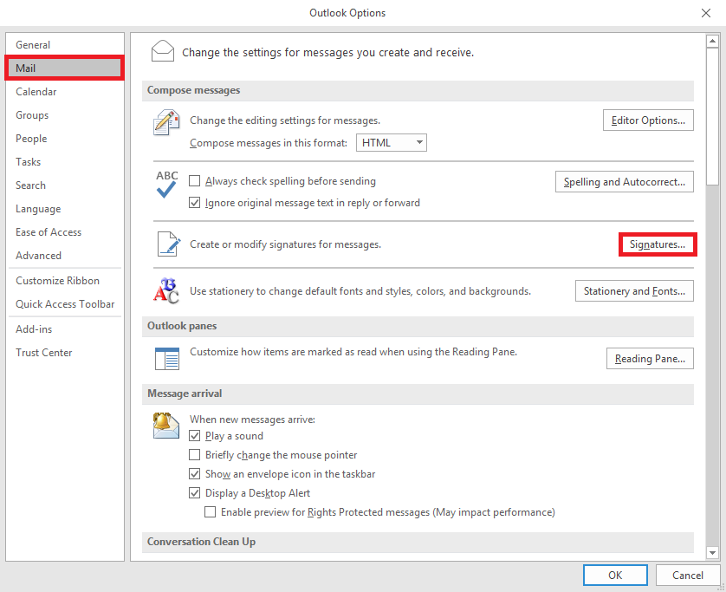

3. Select **NEW**, type in a **NAME** for the signature you’re creating and copy & paste the template. **MODIFY** and **SAVE**!

